ASP.NET MVC Application Setup document:

GitHub code Path: <https://github.com/senthilpalanisamyfullstackdeveloper/SampleMVC_WebAPI_Application>

**Step #1** Create SQL Database in the Name of **PWCustomer** and Table name as **Customers**

I’ve attached the Table creation SQL script file here - [Customer_Table_Creation.sql](https://github.com/senthilpalanisamyfullstackdeveloper/SampleMVC_WebAPI_Application/blob/main/Customer_Table_Creation.sql)

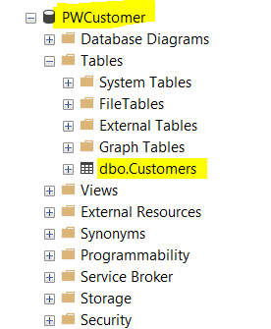

**Step #2** Download the source from here.

Web application source code is here - [Senthil.Customer.SampleApp](https://github.com/senthilpalanisamyfullstackdeveloper/SampleMVC_WebAPI_Application/tree/main/Senthil.Customer.SampleApp)

Web API service source code is here - [Senthil.Customer.Api.Sample](https://github.com/senthilpalanisamyfullstackdeveloper/SampleMVC_WebAPI_Application/tree/main/Senthil.Customer.Api.Sample)

**Step #3** Make the connection string change under web.config in Customer.Web.Api project.

i.e Data Source and DB name highlighted below.

<connectionStrings>

<add name="PWCustomerEntities" connectionString="metadata=res://*/CustomerDBModel.csdl|res://*/CustomerDBModel.ssdl|res://*/CustomerDBModel.msl;provider=System.Data.SqlClient;provider connection string=&quot;data source=PCL291081\PCL291081;initial catalog=PWCustomer;integrated security=True;MultipleActiveResultSets=True;App=EntityFramework&quot;" providerName="System.Data.EntityClient" />

</connectionStrings>

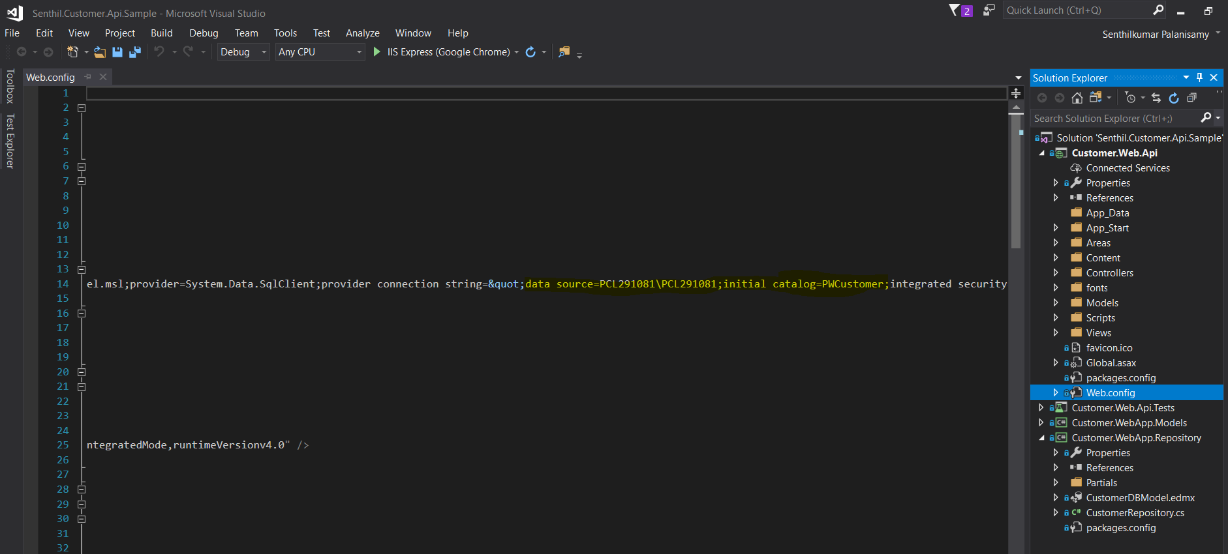

**Step #4** Build and Run the web api project, you will get the URL as <http://localhost:57225/>

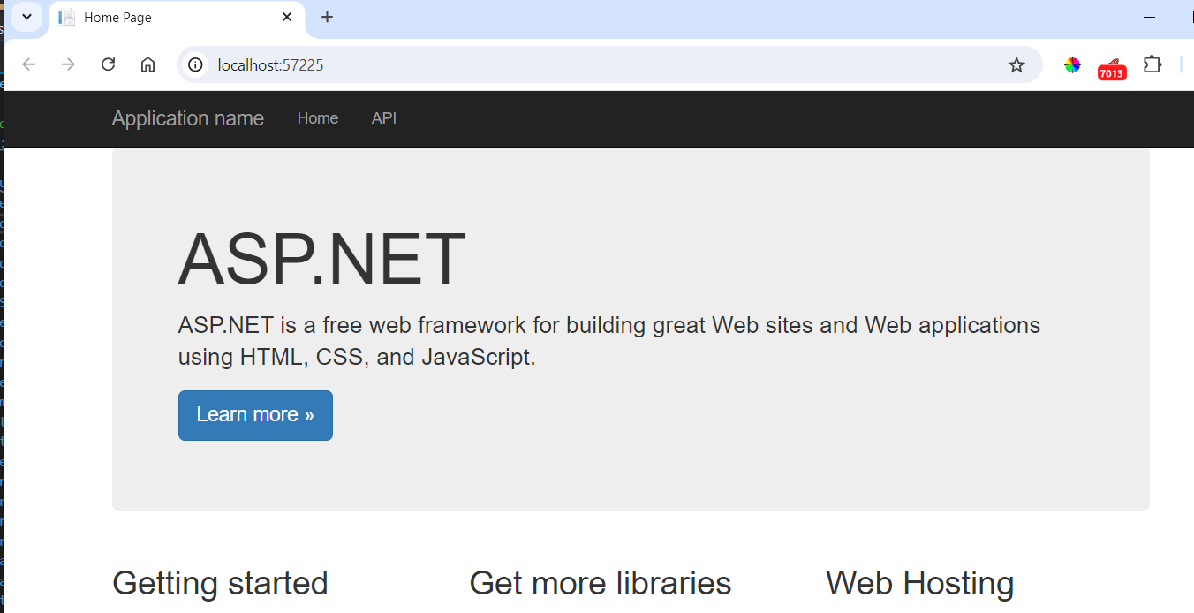

**Step #5** Now the API url - <http://localhost:57225/> to be updated in the Web application config file as below,

<add key="ApiURL" value="http://localhost:57225/api/customer" />

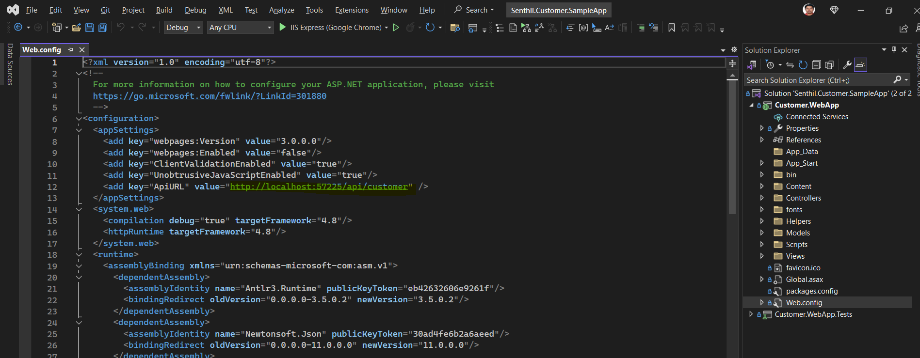

**Step #6** Now build and run the web application.

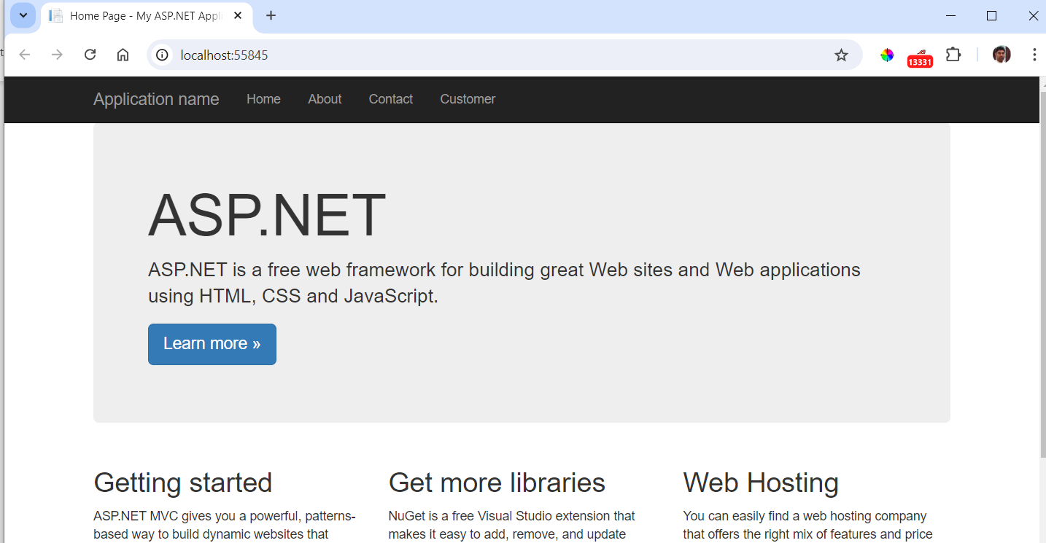

Click on the Customer link, then you can see the Index page. Here, you have option to Create New Customer and Edit/Delete existing customers.

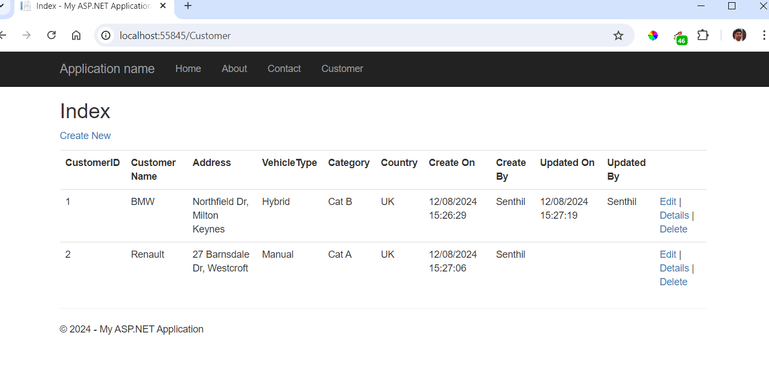

View customer details.

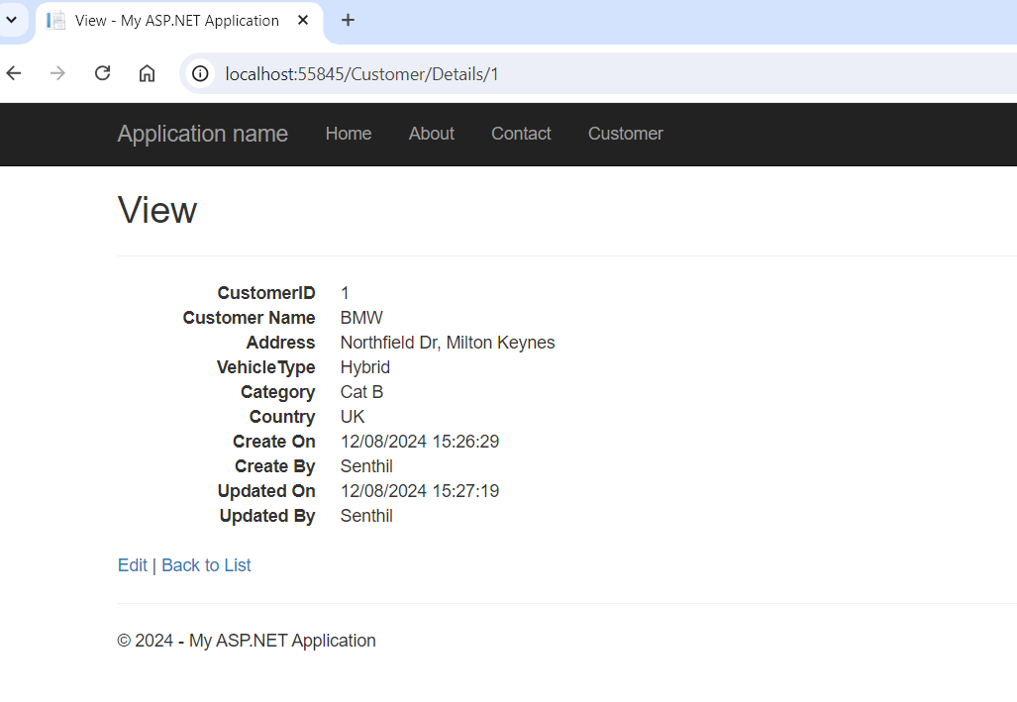

Edit Customer Details,

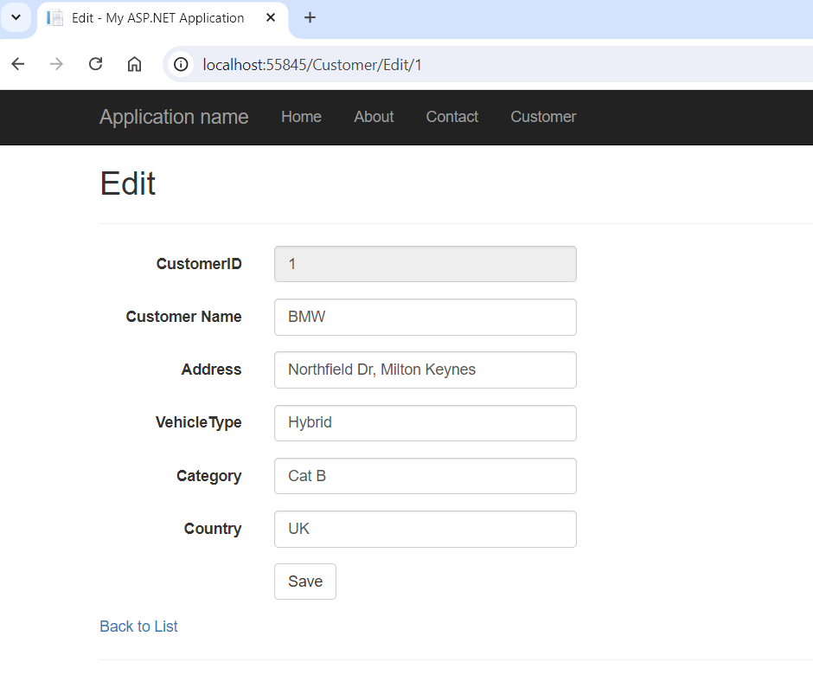

SQL query to view the data,

SELECT TOP (1000) [CustomerID]

,[CustomerName]

,[Address]

,[VehicleType]

,[Category]

,[CountryName]

,[CreatedOn]

,[CreatedBy]

,[UpdatedOn]

,[UpdatedBy]

FROM [PWCustomer].[dbo].[Customers]

